Prompt Ladder Assignment – Frontend AI Engineering
Topic:
Improving a frontend coding prompt through five iterations one layer at a time.
Project theme: Todo App UI. Tech choice (simple): React + Vite + CSS

Baseline
Prompt:
“Build a todo app frontend.”
Representative Output:
- What changed in the prompt: None (baseline).
- What improved in the output: N/A
- What still failed: Too vague; unclear features, no structure, inconsistent code.
- What I would try next: Add a clearer goal.

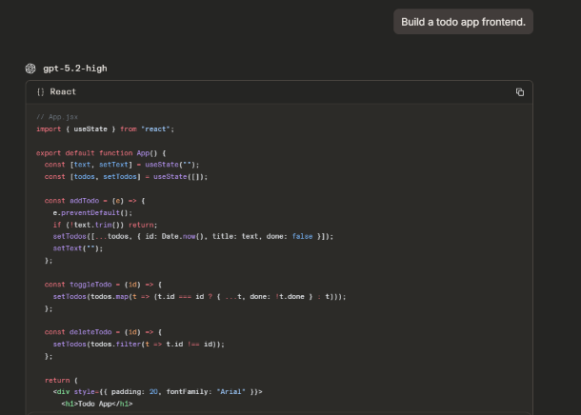

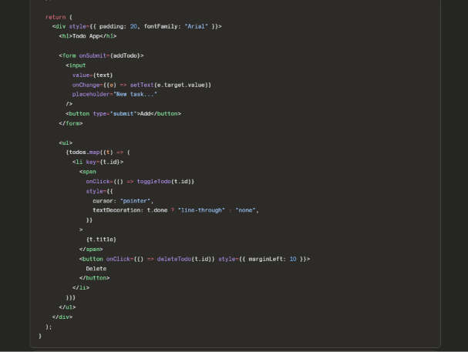

Version 1 — Layer: Clearer Goal
Prompt:
“Build a Todo app frontend in React with these features: add a task, list tasks, toggle complete, edit a task title, and delete a task.”
Representative Output:
- What changed in the prompt: Added a clearer goal (specific features).
- What improved in the output: The output included the missing UI actions, especially edit, Save, and Cancel, instead of only showing a basic todo list.
- What still failed: Still missing real project context (how to start, what files, what tooling).
- What I would try next: Add real context.
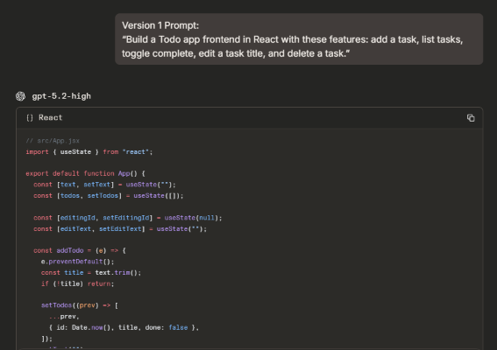

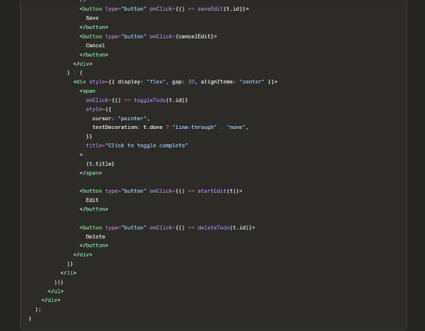

Version 2 — Layer: Real Context
Prompt:
“Build a Todo app frontend in React with these features: add, list, toggle complete, edit title, delete. This is for a beginner portfolio project using Vite + React, with no backend (use local component state only).”
Representative Output:
- What changed in the prompt: Added real context (beginner portfolio + Vite + no backend).
- What improved in the output: The output used local React component state and did not add backend code or API calls, so it matched a beginner Vite project.
- What still failed: Response can still be messy (no clear sections / files).
- What I would try next: Specify output format.

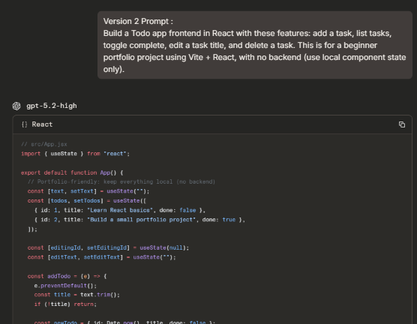

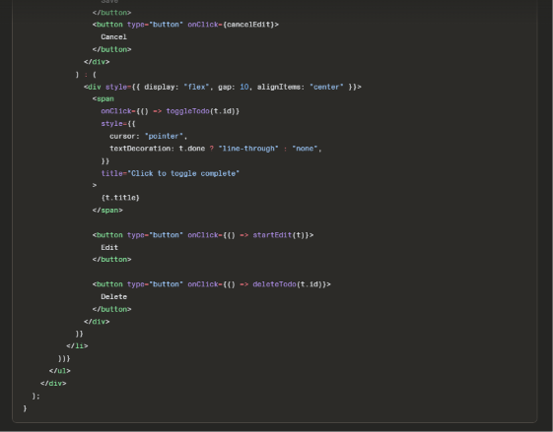

Version 3 — Layer: Specified Output Format
Prompt:
“Build a Todo app frontend in React with these features: add, list, toggle complete, edit title, delete. This is for a beginner portfolio project using Vite + React, with no backend (use local state only). Organize your answer into exactly these sections: (1) File/Component Structure, (2) Code, (3) How to Run, (4) Manual Test Steps.”
Representative Output:
- What changed in the prompt: Added a specified output format (4 sections).
- What improved in the output: The output was organized into the exact 4 sections (File/Component Structure, Code, How to Run, Manual Test Steps), so it was easier to follow and copy/paste.
- What still failed : Even with sections, the response could still be verbose and it didn’t guarantee accessibility/responsive details unless explicitly required.
- What I would try next: Add quality criteria.
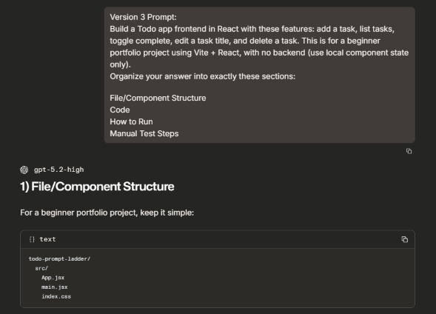

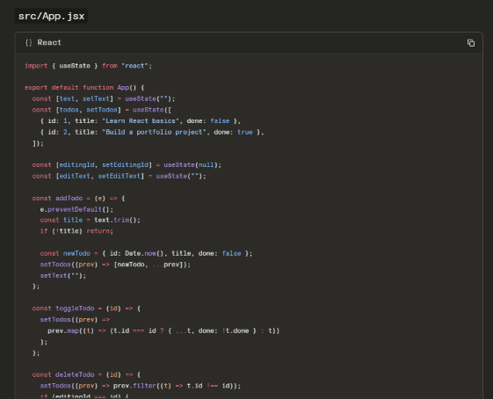

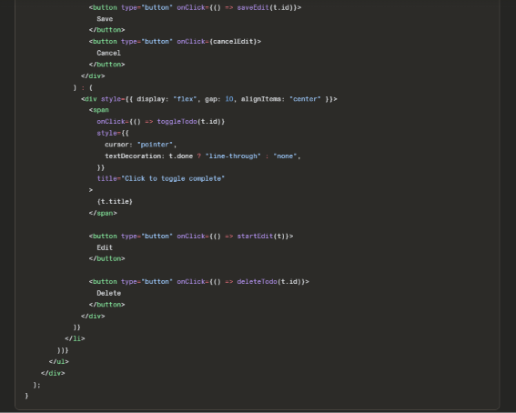

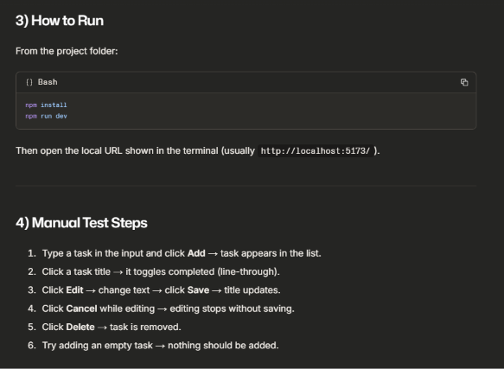

Version 4 — Layer: Quality Criteria
Prompt:
“Build a Todo app frontend in React with these features: add, list, toggle complete, edit title, delete. This is for a beginner portfolio project using Vite + React, with no backend (use local state only). Organize your answer into: (1) File/Component Structure, (2) Code, (3) How to Run, (4) Manual Test Steps.
Quality criteria: use semantic HTML, accessible form labels, keyboard-friendly controls, and mobile-first responsive layout.”
Representative Output:
- What changed in the prompt: Added quality criteria (a11y + semantic + responsive).
- What improved in the output: The output used semantic elements, connected labels with inputs, a real checkbox for keyboard-friendly task toggling, and responsive CSS for smaller screens.
- What still failed (honest): The output became longer because it included extra CSS and accessibility-related markup, which made it harder to read and paste quickly as a beginner.
- What I would try next: Add verification requirements (self-check list).
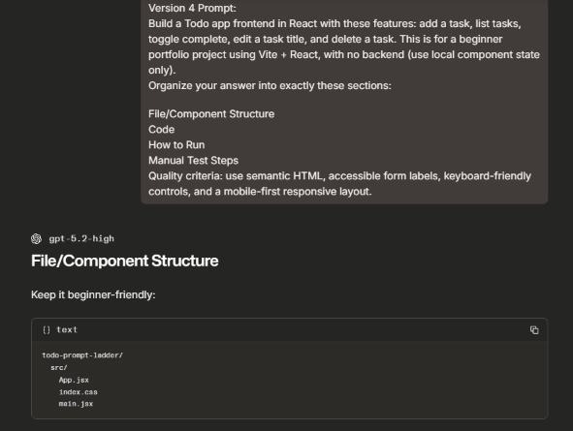

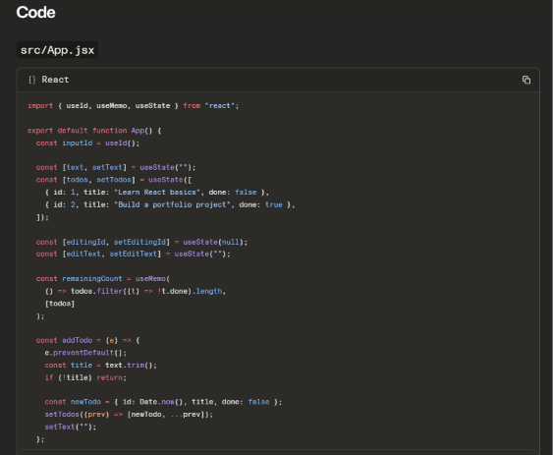

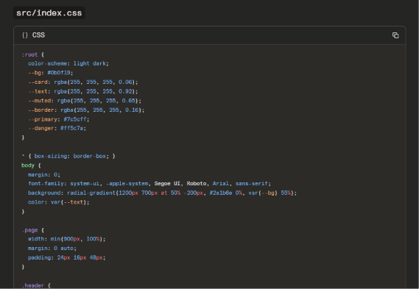

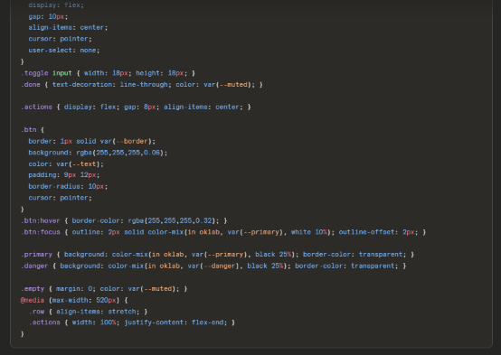

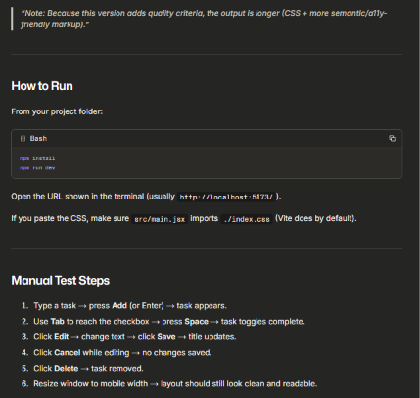

Version 5 — Layer: Verification Requirements
Prompt:
“Build a Todo app frontend in React with these features: add, list, toggle complete, edit title, delete. This is for a beginner portfolio project using Vite + React, with no backend (use local state only).
Organize your answer into: (1) File/Component Structure, (2) Code, (3) How to Run, (4) Manual Test Steps.
Quality criteria: semantic HTML, accessible labels, keyboard-friendly controls, mobile-first responsive layout.
At the end, add: (A) Assumptions you made, (B) a verification checklist with 6 bullets to confirm it works.”
Representative Output:
- What changed in the prompt: Added verification requirements (assumptions + checklist).
- What improved in the output: The output ended with assumptions and a six-item verification checklist, making the limitations and testing steps clear.
- What still failed: Often increases length (extra text). If too long, you’d make verification optional next time.
- What I would try next: Add constraints like “keep code under X lines” OR examples.
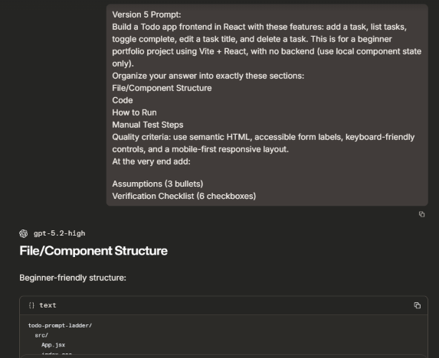

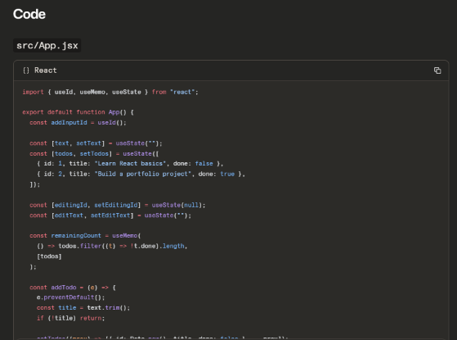

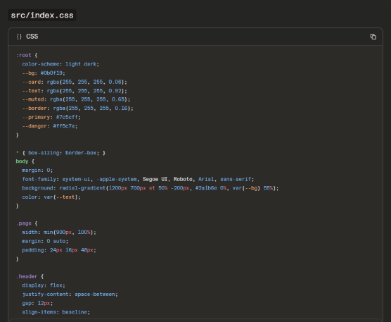

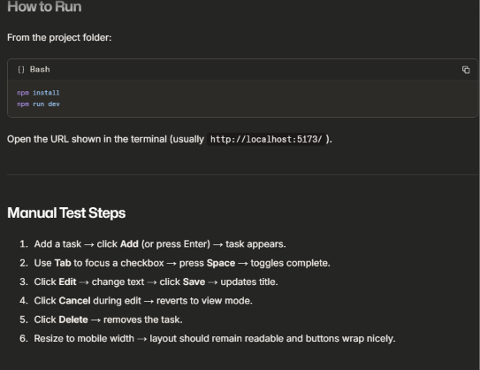

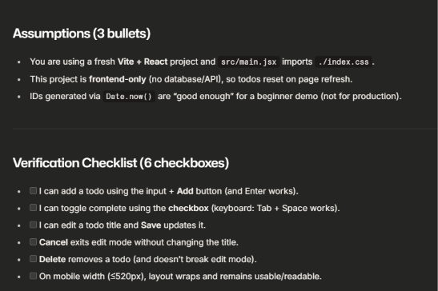

Final Reusable Prompt (Frontend — React + Vite)
Prompt:
Build a Todo app frontend in React for a beginner portfolio project using Vite + React. This is frontend-only (no backend/API). Use local component state only.
Required features:
Add a task, List tasks, Toggle complete/incomplete, Edit a task title (Save + Cancel), Delete a task.
Organize your response into exactly these sections:
File/Component Structure, Code, How to Run, Manual Test Steps.
Quality criteria:
Use semantic HTML (main/header/section where appropriate), Use accessible form labels (label + htmlFor/id), Controls must be keyboard-friendly (Tab navigation; toggling should work without relying on click-only), Mobile first responsive layout (should remain usable on small screens).
At the very end, include:
Assumptions (exactly 3 bullet points), Verification Checklist (exactly 6 checkboxes).
Important constraints:
Keep it beginner-friendly (clear variable names, short comments only where necessary), Do not use external UI libraries (no Tailwind/Bootstrap/MUI) unless explicitly asked, Do not add backend code or API calls.

